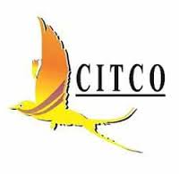
Chandigarh Industrial & Tourism Development Corporation Limited
CIN: U45202CH1974SGC003415
Regd Office: SCO 121-122, Sector 17-B, Chandigarh – 160017
Phone No. 0172 – 4644430-34, Fax No. 0172-4644441
Email: tourism@citcochandigarh.com website: www.citcochandigarh.com

OPPORTUNITY FOR SOLO ARTIST

Offers invited from solo artist with talent and finesse to perform on contractual basis in four star Hotel Shivalikview in Chandigarh. A solo artist single performer i.e. Singer who can also play Casio/Guitar/Piano etc. having minimum three years experience may apply online on tourism@citcochandigarh.com by 09.09.2021 upto 5.00 P.M to Managing Director, CITCO and should report for audition alongwith musical instruments on 15.09.2021 t 11:00 A.M at Cloud -9, Hotel Shivalikview, Sector-17, Chandigarh.

Remuneration shall be paid in accordance with the performance and experience.

MD reserves the right to accept/reject any or all offers without assigning any reason.

MANAGING DIRECTOR
CITCO.

